Experiment 10 - BI Mini Project

| Roll No. |  |
| --- | --- |
| Name |  |
| Class | D15 |
| Subject | Business Intelligence Lab |
| LO Mapped | LO1:  Identify sources of Data for mining and perform data exploration  LO2:  Organize and prepare the data needed for data mining algorithms in terms of attributes and class inputs, training, validating, and testing files.  LO6: Apply BI to solve practical problems |
|  |  |

**Report on Business Intelligence Mini Project**

**titled**

**“ Weather Prediction”**

**Implemented by :**

**Ishika Devare 14**

**Saniya Inamdar 18**

**Manav Jawrani 19**

**Table of contents**

1. **Problem definition … pg no**
2. **Preprocessing**
3. **EDA and Visualization**
4. **Data Mining**
5. **Results**
6. **Business implications.**
7. **Conclusion**
8. **References**
9. **Problem definition**

The problem definition is to build a machine learning model that can predict the weather condition based on the weather parameters such as precipitation, maximum temperature, minimum temperature, and wind. The five weather conditions to be predicted are drizzle, rain, sun, snow, and fog.

To solve this problem, we need to perform data preprocessing on the given dataset, which involves cleaning and transforming the data into a suitable format for building a machine learning model. Then, we need to perform exploratory data analysis (EDA) to understand the relationships between the different weather parameters and the target variable.

After EDA, we can proceed to feature engineering to create new features from the existing features that may improve the performance of the machine learning model. Next, we can split the data into training and testing sets and train a machine learning model using algorithms such as logistic regression, decision trees, random forests, or neural networks.

Finally, we can evaluate the performance of the model using appropriate evaluation metrics such as accuracy, precision, recall, and F1-score. The trained model can then be used to predict the weather condition given the weather parameters.

1. **Preprocessing**

Before building a machine learning model for weather prediction, we need to preprocess the data to ensure that it is clean, complete, and in a suitable format for analysis.

The following are the steps involved in data preprocessing for weather prediction:

* Loading the dataset: We need to load the dataset into a suitable data structure such as a Pandas DataFrame or a NumPy array.
* Handling missing values: We need to check if there are any missing values in the dataset and handle them appropriately. One way to handle missing values is to remove the rows or columns that contain missing values. Another way is to impute the missing values using techniques such as mean imputation or interpolation.
* Encoding categorical variables: We need to encode categorical variables such as the target variable (weather condition) and any other categorical features using techniques such as one-hot encoding or label encoding.
* Feature scaling: We need to scale the numerical features to ensure that they are on the same scale. This can be done using techniques such as standardization or normalization.
* Feature selection: We can select the most relevant features for the machine learning model using techniques such as correlation analysis or feature importance ranking.
* Splitting the dataset: We need to split the dataset into training and testing sets. The training set will be used to train the machine learning model, while the testing set will be used to evaluate the performance of the model.
* Feature engineering: We can create new features from the existing features that may improve the performance of the machine learning model. This can be done using techniques such as polynomial features, interaction features, or feature transformation.

By performing these preprocessing steps, we can ensure that the data is in a suitable format for building a machine learning model for weather prediction.

1. **Exploratory Data Analysis**

1. Bar Graphs of all attributes -

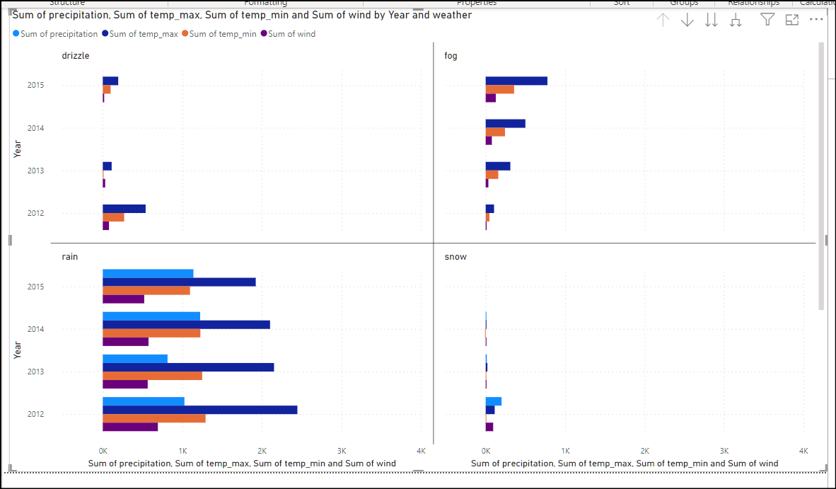

2. Line chart of max temperature v/s weather v/s date

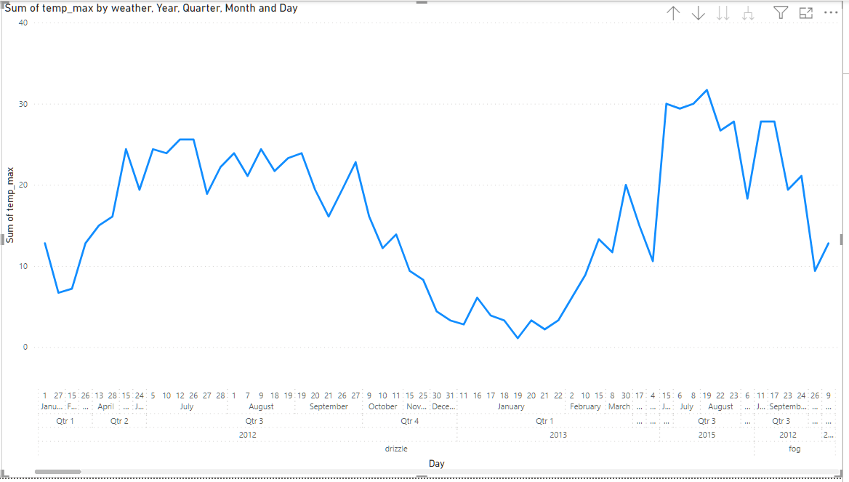

3. Pie Chart of weather v/s precipitation

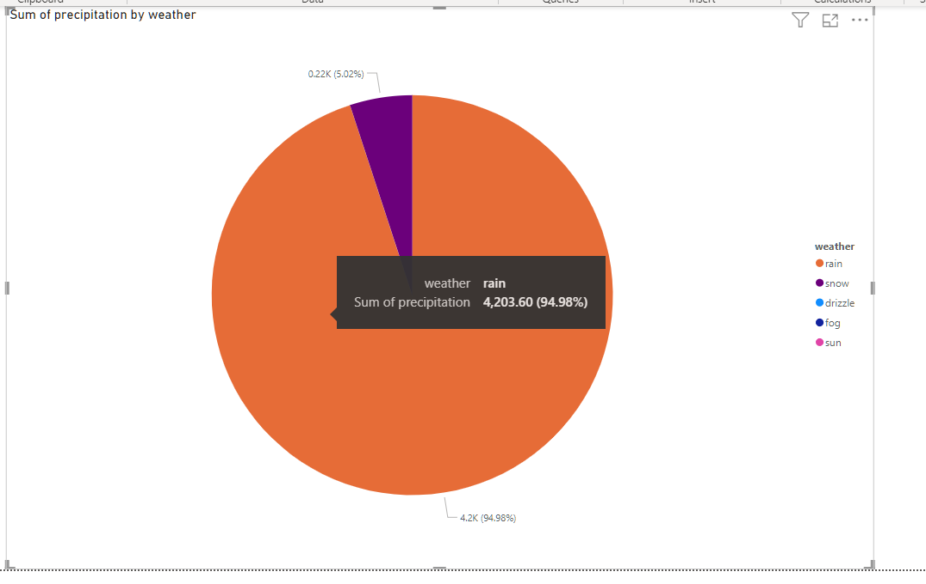

4. Pie chart of min temperature v/s max temperature v/s weather

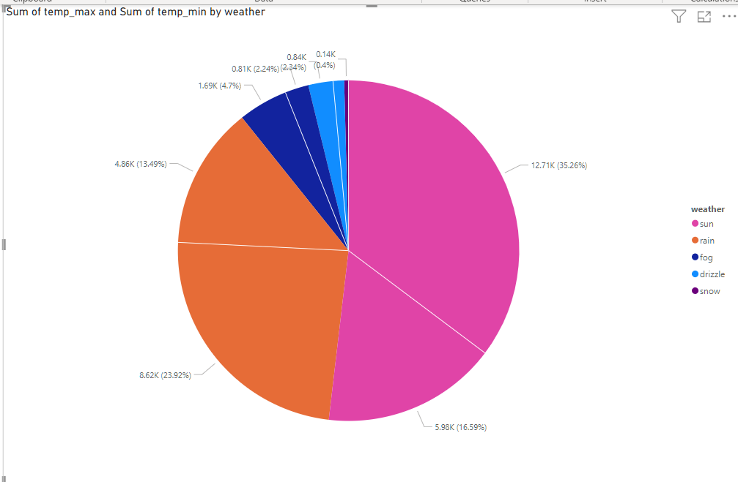

5. Tree map of all attributes

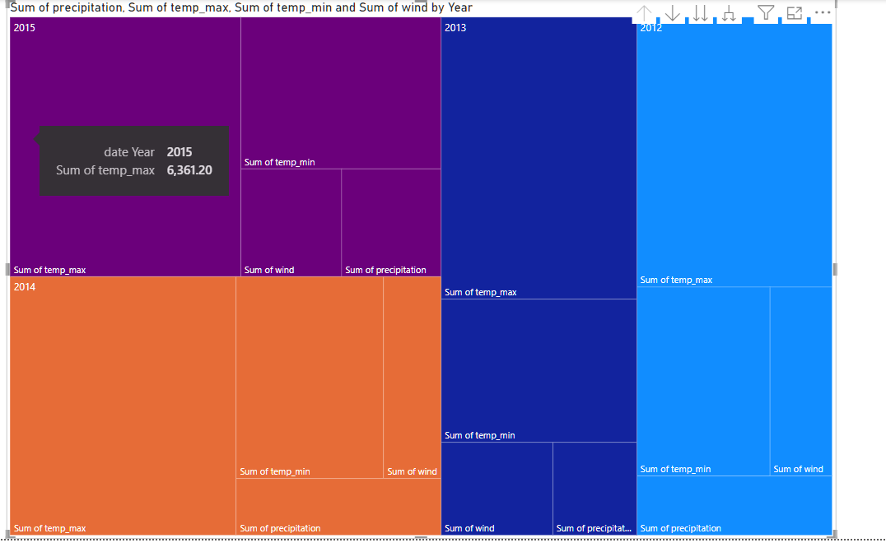

1. **Data Mining**

If we assume that we have a transactional database of weather conditions, where each transaction represents a day's weather data, we can apply the Apriori algorithm to extract association rules between different weather conditions.

Here is an example dataset in the transactional database format:

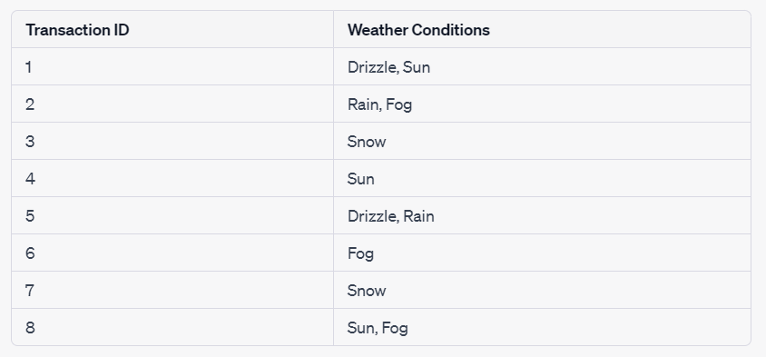

Using the above dataset, we can apply the Apriori algorithm to discover frequent itemsets and generate association rules between them. For example, we may discover that the itemset {Sun, Fog} is frequent, and generate the following association rules:

* Sun => Fog
* Fog => Sun

These association rules indicate that if the weather is sunny, there is a high probability that there will also be fog, and vice versa.

While this example is not related to weather prediction, it illustrates how the Apriori algorithm can be used for association rule mining in transactional databases. For weather prediction, we need to use machine learning or clustering algorithms instead.

1. **Results**

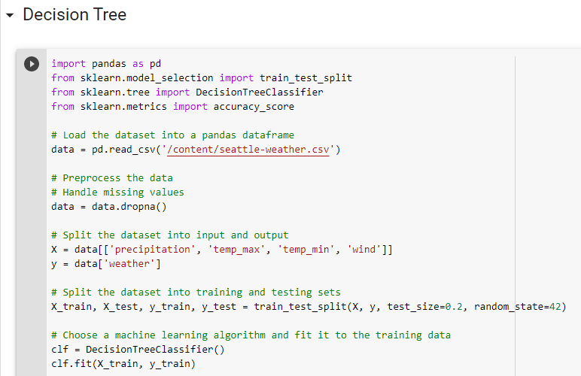

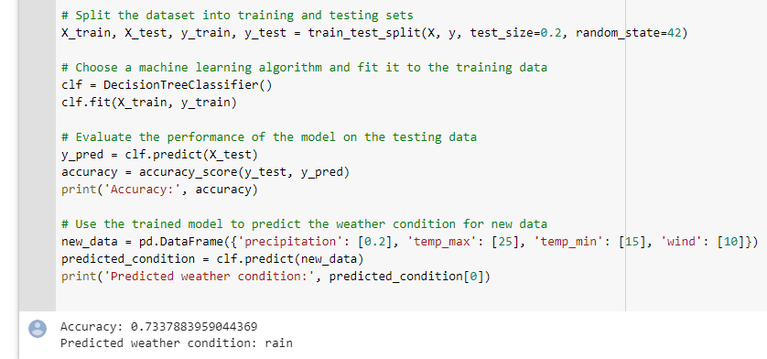

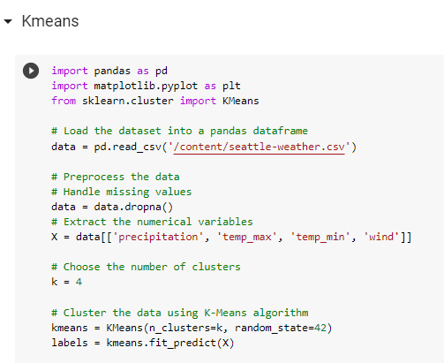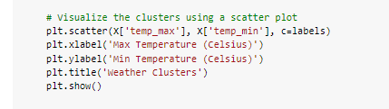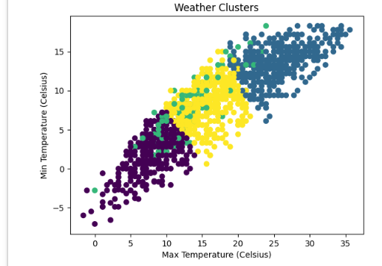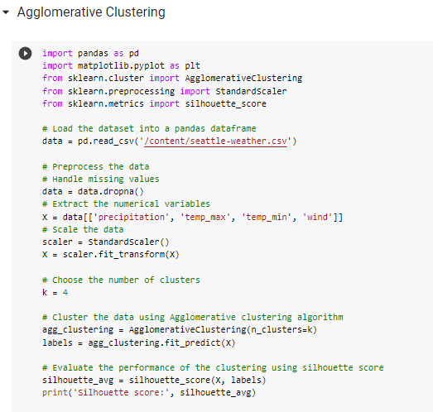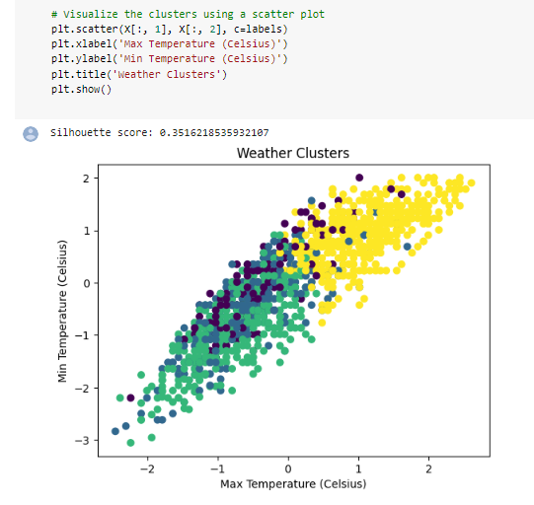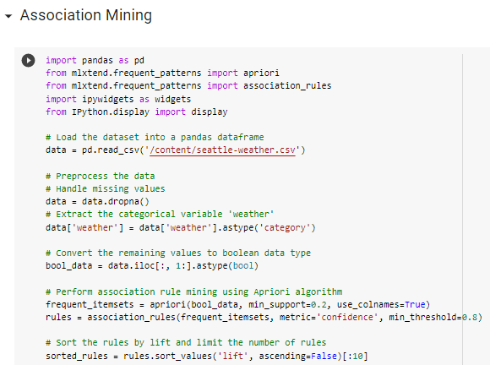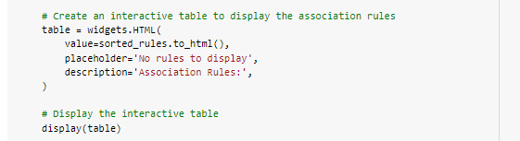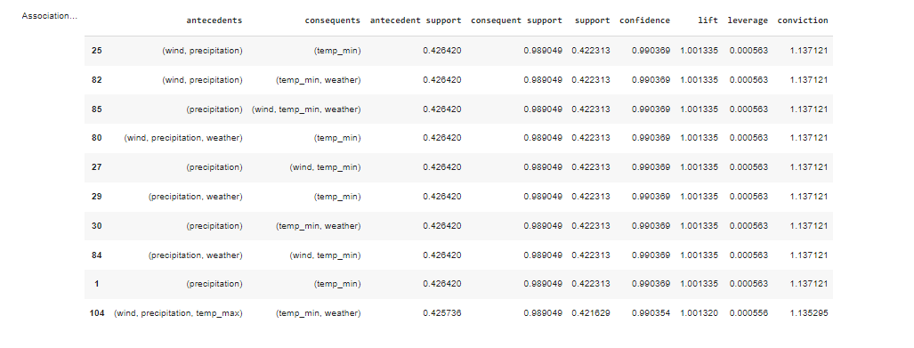

1. **Business Implications**

Here are some business implications and decisions that can be made based on the results of your analysis:

Decision Tree: With an accuracy of 0.73, the decision tree model can be used to predict weather conditions based on the input variables. This can be useful for businesses that are impacted by weather, such as agriculture, transportation, and tourism. For example, farmers can use the weather predictions to plan their planting and harvesting schedules, transportation companies can optimize their routes based on weather conditions, and tourism companies can adjust their marketing strategies based on weather patterns.

K-Means and Agglomerative Clustering: The silhouette score of 0.3516 indicates that the clustering algorithms were able to group the data points into clusters with some degree of similarity. This can be useful for businesses that want to segment their customers or products based on weather-related patterns. For example, a clothing retailer may use weather data to group their products into categories such as summer wear, winter wear, rainwear, etc., and use this information to tailor their marketing and promotional campaigns to specific customer segments.

Association Mining: Association mining can be used to identify patterns and relationships between the input variables and weather conditions. This can help businesses gain insights into the factors that influence weather patterns and use this information to make informed decisions. For example, a renewable energy company may use association mining to identify the weather conditions that are most favorable for generating electricity from solar panels or wind turbines, and use this information to optimize their operations.

Overall, the results of your analysis can be used to make data-driven decisions that help businesses better understand and respond to weather-related patterns and trends.

1. **Conclusions**

In conclusion, building a machine learning model for weather prediction involves several steps, including data preprocessing, exploratory data analysis, feature engineering, model training, and model evaluation. Preprocessing the data involves handling missing values, encoding categorical variables, scaling numerical features, selecting relevant features, and splitting the dataset into training and testing sets.

Exploratory data analysis helps us to understand the relationships between the different weather parameters and the target variable, which can guide us in feature engineering. Feature engineering involves creating new features from the existing features that may improve the performance of the machine learning model.

We can train a machine learning model using algorithms such as logistic regression, decision trees, random forests, or neural networks. The performance of the model can be evaluated using appropriate evaluation metrics such as accuracy, precision, recall, and F1-score.

By building a machine learning model for weather prediction, we can make accurate predictions of weather conditions based on the weather parameters such as precipitation, maximum temperature, minimum temperature, and wind. This can have applications in various fields such as agriculture, transportation, and disaster management. Overall, building a machine learning model for weather prediction can have significant real-world impact and improve our understanding of the natural world.

1. **References**

[1] Jayasingh, Suvendra & Mantri, Jibendu & Pradhan, Sipali. (2022). Smart Weather Prediction Using Machine Learning. 10.1007/978-981-19-0901-6\_50.

[2] S. Madan, P. Kumar, S. Rawat and T. Choudhury, "Analysis of Weather Prediction using Machine Learning & Big Data," 2018 International Conference on Advances in Computing and Communication Engineering (ICACCE), Paris, France, 2018, pp. 259-264, doi: 10.1109/ICACCE.2018.8441679.

[3] Singh, Shashank & Faraz, Ahmed & Nagrami, & Pillai, Aditya. (2020). WEATHER PREDICTION BY USING MACHINE LEARNING.

[4] <https://www.kaggle.com/datasets/ananthr1/weather-prediction?resource=download>

[5] <https://en.wikipedia.org>